CSE301 Bio-computation, 2016
Week 12 Tutorial Exercises on LVQ and Associative Memory

Q1. Describe the relationship between the Self-Organising Map algorithm, and the Learning Vector Quantisation algorithm.

Answer:
In order to use Learning Vector Quantisation (LVQ), a set of approximate
reconstruction vectors is first found using the unsupervised SOM algorithm. The supervised LVQ algorithm is then used to fine-tune the vectors found using SOM.

Q2. Briefly explain the term code book in the context of learning vector quantization

Answer:
When compressing data by representing vectors by the labels of a relatively small set of reconstruction vectors, the set of reconstruction vectors is called the code book.

Q3. Hopfield networks are most often used for auto-association. What does that mean, and why can this be useful at all?

Answer:
Auto-association is a network’s ability for a certain number of stored patterns, whenever they are input to the network, to produce the same pattern as its output. This is useful if the network is still able to output precisely the stored pattern even if the input pattern is noisy, i.e., slightly deviates from the stored one. In this case, the network can be used to remove noise from known input patterns.

Q4. Why do we demand for auto-association that all wii = 0?

Answer:
If we did not demand this, the trivial solution wii = 1 and wij = 0 for i ≠ j could be
chosen, which formally leads to auto-association for all input patterns but does not store any pattern information and cannot be used for error correction. With wii = 0 we ensure that the pattern information (the correlation between pairs of pixels) is stored in the connections between neurons.

Q5. Write down the energy function of a discrete Hopfield net

Answer:
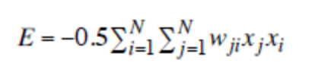
Q6. Please explain how it can be shown that for a constant input, Hopfield networks are guaranteed to reach a stable state after a finite number of iterations. You do not have to write down any equations, but just describe the concepts that are introduced and why they prove this property of Hopfield networks.

Answer:
First, we introduce an energy function in such a way that it decreases whenever the state of the network gets closer to one of the stored patterns. Every possible state has a
particular energy value. Then we show that whenever the Hopfield rule demands that the state of a neuron switches, the network energy decreases. Since in the discrete Hopfield network there is only a finite number of possible states, it means that after a finite number of switches a state will be reached in which no further switches can occur because none of them would lower the energy.

Q7. Compute the weight matrix for a 4-neuron Hopfield net with the single fundamental memory ξ₁ = [1,–1, –1,1] stored in it.

Answer:
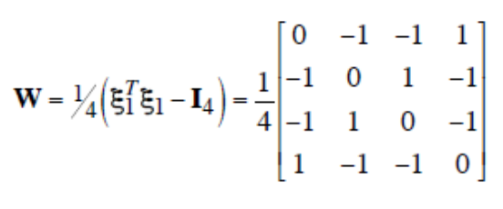

Q8 Hopfield associative memory model is often used for Pattern Completion. Briefly describe it with the aid of the following figure. In the operation, the output is often updated asynchronously. What does this mean?

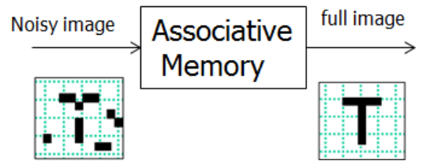

Answer
It is based on the Content Addressable Memory. Partial patterns can be completed to reproduce previously learnt patterns in their entirety; Incorrect patterns (patterns with errors or noise in them) can be corrected if they contain enough correct “bits” in partial patterns for pattern completion

Updating asynchronously means that for a given time, only a single neuron (only one entry in vector v, v=[v₁, …, v_{n}]^{T}, the output vector) is allowed to update its output. The next update in a series uses the already updated vector v:
